|  |  |
| --- | --- |
| A person sitting on a table  Description automatically generated  Enrico Dreyer 31210783 | MySQL LAB 1 Screen shots |

4.1.

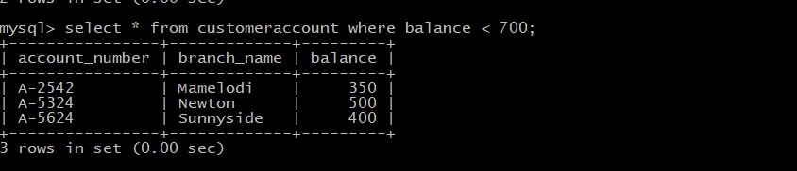

4.2.

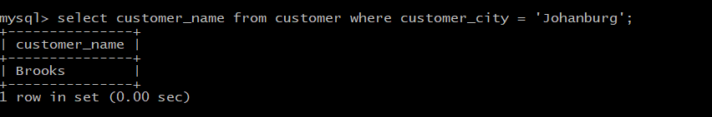

4.3.

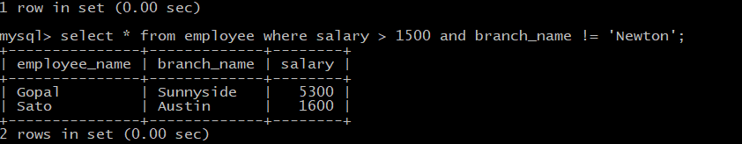

4.4.

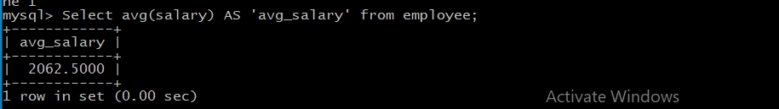

4.5.

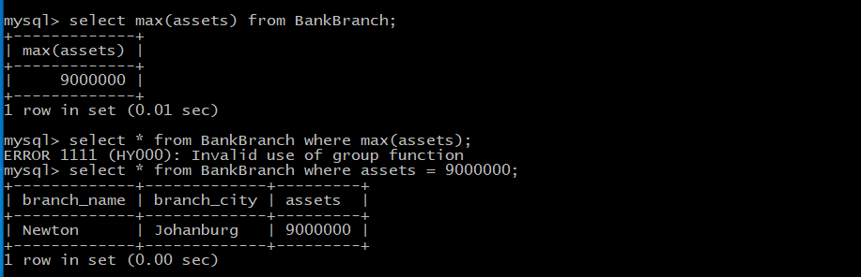

5.1.

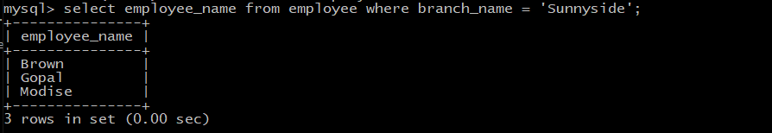

5.2.

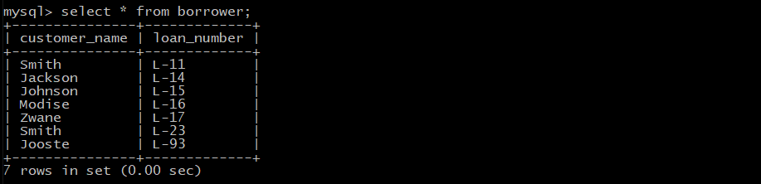

5.3.

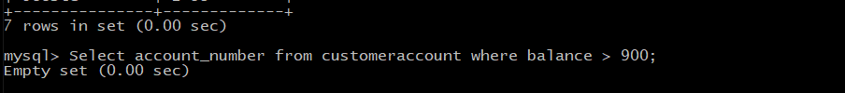

5.4.

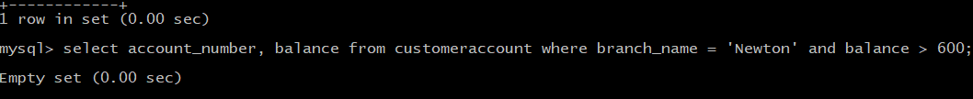

5.5.

